# Analyzing Noninvasive Fetal QRS Detection Techniques

Luiz Medeiros

Department of Computer and Electrical Engineering and Computer Science, Florida Atlantic University, Boca Raton Florida

**Abstract**

*There are a number of proposed algorithms for the analysis and detection of fetal QRS complexes. This paper attempts to primarily test and document the proposed algorithms mentioned in a number of papers proposed for the Physionet/CinC Challenge [1][2][3].  
 The importance of detecting the FQRS Complex (Fetal QRS Complex) lies on the value of the information. Many complications that may arise through pregnancy may be initially detected through abnormalities on the QRS complex of the fetus. By properly detecting these abnormalities, one is able to address problems in a timely fashion, thereby giving professionals a much larger chance to be able to properly remediate a situation.*

**Introduction**

The QRS complex is part of the delineation given to a common, observable physical phenomenon that occurs in the heart.   
Essentially part of the PQRST wave, the QRS Complex is commonly seen as part of a depolarization process that occurs in the ventricles of the heart [4]. This is captured by measuring these electrical activities and subsequently plotting their values against a calibrated discrete value vs Time graph.

It is important to note that a normal heart property is the occurrence of an electrical pulse which subsequently induces a mechanical force [4]. Through this physical logic, by primarily detecting abnormalities in the electrical pulses generated by the heart, we are able to detect subsequent abnormalities in the pumping mechanism and thus blood flow. An action of utmost importance when considering the health of the fetus.

Now, the challenges that arise when tackling the problem of identifying the FQRS occur in a number a number of stages. First, it is difficult to properly compare a large array of AECGs (Abdomen ECGs) because there is yet to be established a standard for recording these signals. Second, there is a challenge in separating MECGs and noise to later attain the FECG. One of the reasons for this challenge is the amplitude of the captured MECG signal is significantly larger than the FECG [1]. In addition, there exists a significant amount of noise occurring at overlapping frequencies [1][2]. Thus, the preprocessing (later mentioned in the algorithm section) is a very important step in achieving an accurate solution.

**Overall Algorithms**

The top-down algorithm suggested by Perlman *et al.* [1] is comprised of the following steps:

1. Pre-Processing
2. MQRS Detection
3. Initial FQRS Candidates Detection
4. MECG Cancellation
5. A Modified Linear Combiner
6. Post-Processing

This process is explored is and analyzed by primarily retrieving suitable signal examples from *Physionet.org*, where the signals were annotated and professionally monitored and retrieved.

**Pre-Processing**

The pre-processing section of the application and analysis is paramount, as mentioned previously. The first step into the pre-processing is then to present the signals graphically, along with their Fast Fourier Transform (fft) resultant. Following this approach, a band pass filtering technique is utilized to restrict our signal between 10Hz and 49Hz. This alleviates common land line noises encountered at 50 and 60Hz and restricts the result to the general low band of interest, where our FECG is located.

In addition, this also takes away a portion of the amplitude from the MECG [1][5], patient movement and other baseline high energy, low frequency (2Hz -10Hz) components is also the reasoning behind this band pass filter (which are in general generated by amplifier tolerance variances).



Figure 1, A representation of a 2 second portion of all the AECGs

What follows is a series of representations of each respective AECG that is of interest.



Figure 2



Figure 3



Figure 4



Figure 5

All figures have their frequency domain represented in Omega (2*pi*fs).

**Concerns**

Perlman *et al.*  mention a number of papers that were referred to when performing the MECG cancellation step. This was a crucial step into the processing of this information. However, after reviewing paper reference after paper reference, a number of concerns were encountered:

1. This reference system leaves the paper, and a crucial step unclear to the reader, or anyone who is not immediately acquainted with the subject or algorithms mentioned.
2. It is extremely time consuming, and therefore inefficient to be redirected to multiple papers for one piece of information. In addition, it becomes confusing to go through a number of papers looking for one specific information and having to adapt and understand the multiple goals and conventions used in each different paper.
3. Finally, this approach brings discontinuity to the paper and the application of the methods suggested.

With these points mentioned, it should follow that after much research and attempt to understand the number of references named in the main paper [1], the final resort was to create a simple algorithm to test the ideas and move on (due to time constraints).

**Initial FQRS Candidates, MECG Cancellation and Results**

Post the initial preprocessing, it is possible to zoom in the graphs and note the FECG and the MECG. As mentioned by Martens *et al.* , it is correct to place an expectancy of at least one FECG between each MECG [5]. This is due to the fact that the FECG occurs in a fundamental frequency between 2 and 2.7Hz. Special cases also exist, where events like Fetal Bradycardia (1.3Hz) and Tachycardia (3.3Hz) allow for the FECG to stray away from the norm.

Below are denoted FECGs that may be perceived from the preprocessed signal.



Figure 6

By the image provided, it is possible to see the smaller, FECG in between the two larger MECG.

The following example provides an image that demonstrates two occurrences of the FECG.

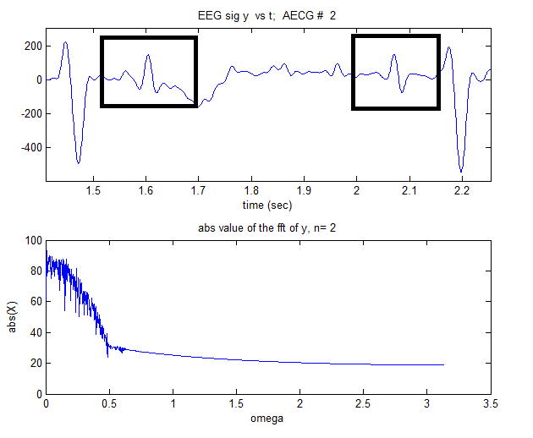

Figure 7, FECG Peaks highlighted

It is also possible to note from the image above the magnitude plot of the fft of the signal (in dB), in addition to the zoomed portion.

Now, in order to achieve the MECG canceling, an algorithm was followed. However, before mentioning the algorithm, a few notes:

* The extreme minima (and their average) from the MECG signals, such as the one seen in figure 7 were taken into account
* The frequency of each of MECG
* The average number of samples containing the duration of each MECG (80 samples).

Martens *et al.* proposed a procedure where an average MECG is chosen to represent the complex. This is then subtracted from the MECG complex in the original signal in order to produce a cleaner ECG and ease the detection of the FECG.

A simple algorithm that closely simulates this idea was performed to solely duplicate the MECG in a separate matrix, say **A**, in the exact location as the detected and then use it against it’s respective AECG to subject the MECG, thereby allowing the FECG to be emphasized. Below is a series of images containing the representative images for each chosen sample and their respective leads.

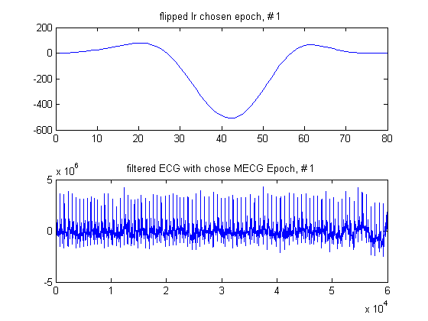

Figure 8

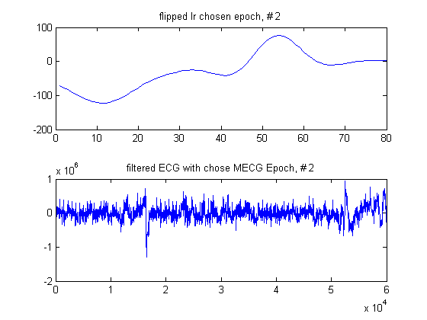

Figure 9

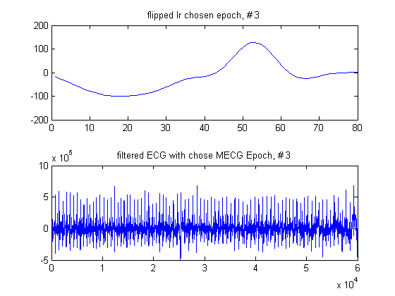

Figure 10

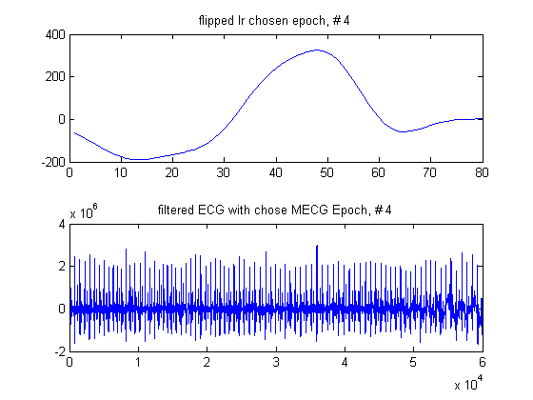

Figure 11

After achieving these respective epochs, it is possible to then move on to the detection of the peaks, which will serve as pinpoints to the filtering process.

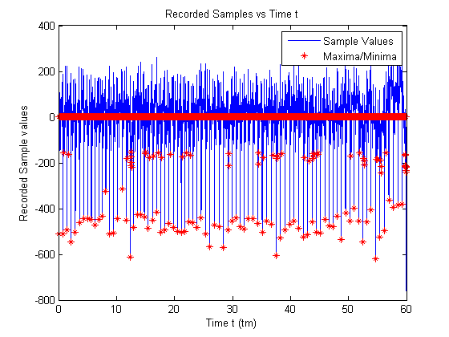

Figure 12

The algorithm first chooses a threshold based on the all the throes below 0. Then it takes the mean of those throes and multiplies them by two to choose a threshold.

The reason for multiplying by two is because it kept the algorithm from choosing a number of potential FECG as cancelling points.

An example of the cancelled MECG for the first lead may be seen on the images below.



Figure 13



Figure 14, Cancelled MECGs and Emphasized FECGs

Figure 14 demonstrates an Emphasized FECG and a series of cancelled MECGs.

In addition, with a small tweak in the algorithm devised to find peaks and throes we are able to then find all the peaks of the FECGs. Furthermore, by reusing the devised algorithms to find the same MECG and it’s peaks, it was possible to also detect and alienate the FECG into it’s own matrix.



Figure 15



Figure 16, The FECG portion of the AECG signal



Figure 17

This provides evidence that the filtering process has been successful.

**Conclusion**

The survey of the proposed solutions to FECG identification was crucial. The overall ideas proposed and concepts discussed were crucial in understanding how and where to go.

The devised algorithms to solve this problem proved generic enough single out MECGs and FECGs. With more research these can be refined and adapted to provide more precise solutions, which may contain further insight and better approximations.

**Reference**

[1] Perlman O, Katz A, Zigel Y, Noninvasive Fetal QRS Detection using a Linear Combination Abdomen ECG Signals.

[2] Christov I, Simova I, Abächerli R, Canellation of the Maternal and Extraction of the Fetal ECG in noninvasive recordings.

[3] Christov I, Real time electrocardiogram QRS detection using combined adaptive threshold.

[4] Sörnmo L, Laguna P, Bioelectrical Signal Procesing in Cardiac and neurological Applications.

[5] Martens S, Rabotti C, Mischi M, Sluijter R, A Robust Fetal ECG Detection Method for Abdomen Recordings.